**SQL Results**

1. 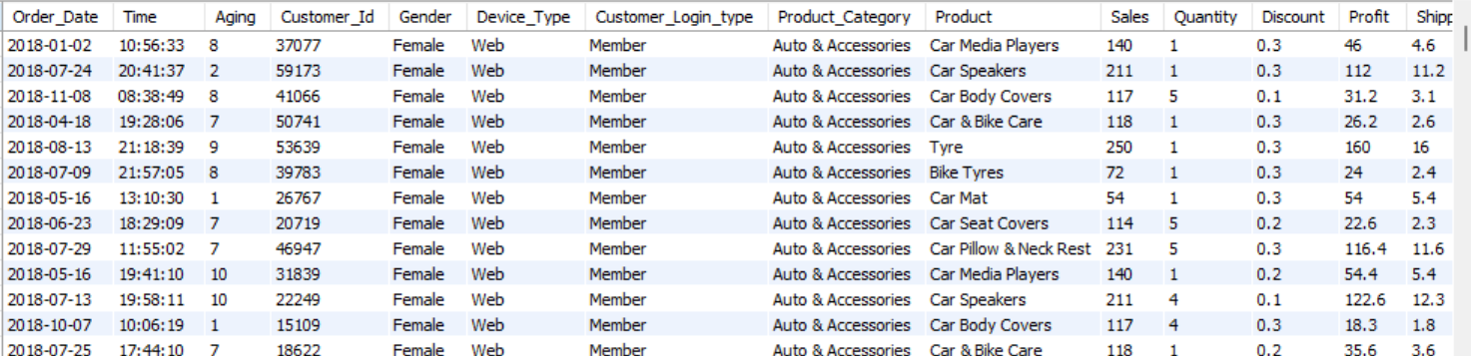
2. Top 10 most expensive Orders

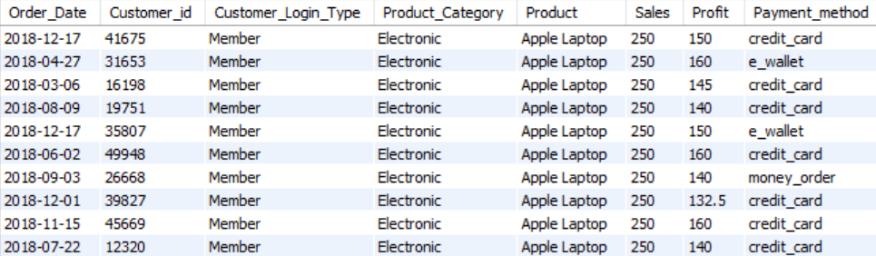

1. Top 10 Profit

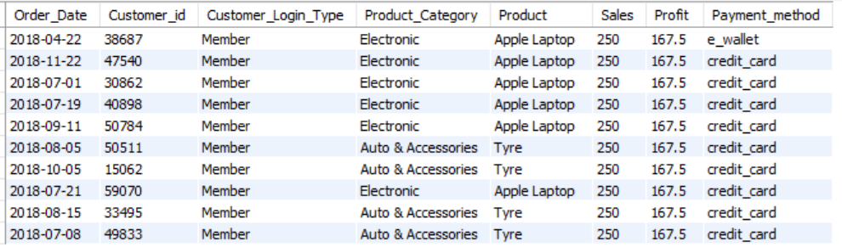

1. Total Sales per Product Category

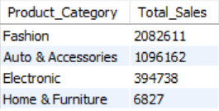

1. Average discount by Payment Method

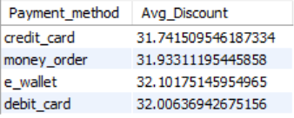

1. Products with sales above average sales

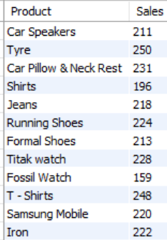

1. Customers with total sales > 200

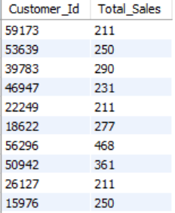

1. Top 5 profitable products

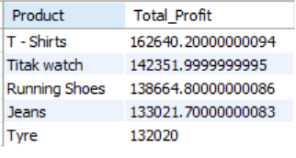

1. Most popular product per category

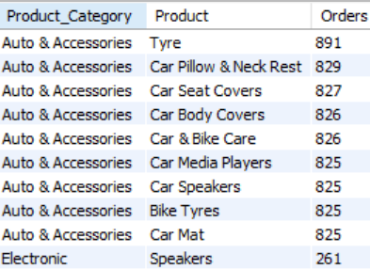

1. Customers who contribute to the top 10% of total sales

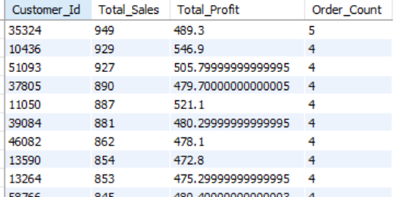

1. Monthly sales trend to plan stock and marketing

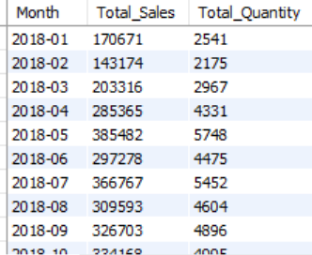

1. Products ranked by profit margin

